**ÔN TẬP KIỂM TRA CUỐI KỲ 1 – 2023-2024**

# TRẮC NGHIỆM KIẾN THỨC TỔNG QUÁT

* 1. **Từ vựng**
  2. **Ngữ pháp: ôn các trọng tâm dưới đây**

**UNIT 1**

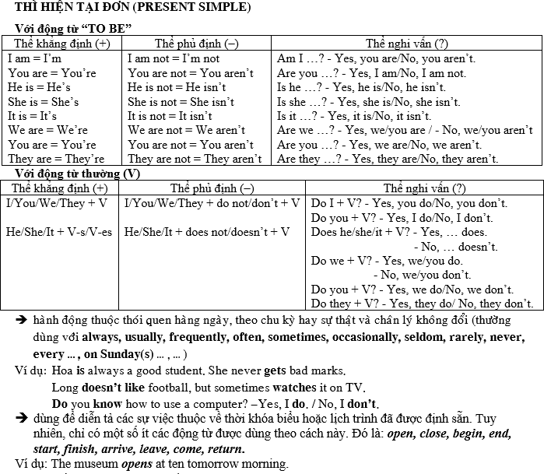

**UNIT 2**

* + - dùng ‘*and*’ với câu khẳng định và ‘*or*’ với câu phủ định Ví dụ: I like milk *and* chocolate.

I don’t like coffee *or* tea.

* + - đại từ sở hữu ‘*mine*’ và ‘*yours*’

Ví dụ: This is my pen. Where’s *yours*? (*yours = your pen*)

Your bike is expensive, but *mine* is cheap. (*mine = my bike*)

**UNIT 3**

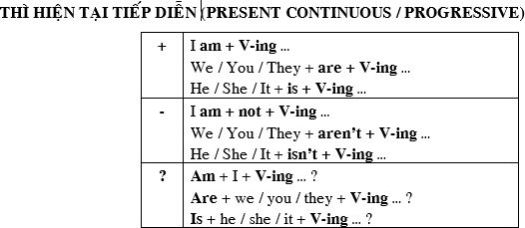

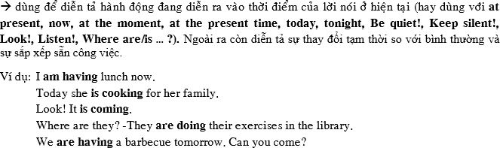

* + - thứ tự của một số tính từ: *kích thước – hình dạng – màu sắc*

Ví dụ: a *big round red* table

**UNIT 4**

* + - trạng từ tần suất (adverbs of frequency): *never, rarely, sometimes, often, usually, always*

đứng sau động từ *be* và trợ động từ *do*, đứng trước động từ thường Ví dụ: You are *always* late.

I don’t *often* go out at night. She *never* comes back here.

**UNIT 5**

* + - 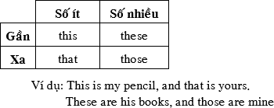chỉ định từ:
    - đại từ túc từ *it* và *them*

Ví dụ: This shirt is nice. I like *it.*

Those shoes are cheap. I can buy *them*.

* + - lượng từ *some* và *any*

*some* và *any* dùng cho cả danh từ đếm được và không đếm được, nhưng *some* được dùng ở thể khẳng định, còn *any* thể phủ định và nghi vấn

Ví dụ: I have *some* toys/money.

I don’t have *any* toys/money. Do you have *any* toys/money?

a/ an: Một ( dùng cho danhtừ đếm được ở dạng số ít)

A: dùng cho các từ bắt đầu bang phụ âm ( a book; a dog)

An: dùng cho các từ bằng phụ âm ( an apple; an orange)

Ngoại lê: a university; an hour;

# BÀI TẬP THỰC HÀNH

## Choose the one word whose underlined part is pronounced differently from that of the others words.

|  |  |  |  |
| --- | --- | --- | --- |
| 1. A. garage | B. yard | C. apartment | D. balcony |
| 2. A. biology | B. history | C. village | D. kitchen |
| 3. A. movie | B. video | C. tomorrow | D. most |
| 4. A. cycling | B. country | C. club | D. school |
| 5. A. things | B. turns | C. ends | D. minutes |
| 6. A. leaves | B. buses | C. chores | D. sometimes |
| 7. A. sports | B. signs | C. books | D. likes |
| 8. A. dances | B. dishes | C. villages | D. activities |

1. ***Choose the one word whose main stress pattern is not the same as that of the others.***

|  |  |  |  |
| --- | --- | --- | --- |
| 9. A. tomorrow | B. apartment | C. restaurant | D. important |
| 10. A. village | B. weather | C. author | D. tonight |
| 11. A. basketball | B. barbecue | C. performance | D. restaurant |
| 12. A. favorite | B. countryside | C. appearance | D. balcony |

1. ***Choose the one word or phrase ( A, B, C or D) that best fits the space in each sentence.***
   1. My favorite subject is history. What’s ?
      1. her B. your C. yours D. their
   2. I don’t like physics, art biology.
      1. and B. or C. for D. so
   3. Does your mother like outdoor activities? -
      1. Yes, she do. B. No, he doesn’t. C. Yes, she is. D. Yes, she does.
   4. What the weather like?
      1. do B. is C. does D. are
   5. Who the kitchen? – My mother.
      1. clean B. cleans C. cleaning D. to clean
   6. What is this city famous ? – Beautiful rivers.
      1. at B. for C. in D. over
   7. The hot weather is very good for food.
      1. grow B. to grow C. growing D. grows
   8. What subjects she ? – She likes art and P.E
      1. does - likes B. does - like C. do - like D. do - likes
   9. How many people in your family?
      1. here are B. is there C. there is D. are there
   10. To pass your turn to someone after finish speaking, say:
       1. Hi! How are you? B. What do you like? C. G Excuse me. D. How about you?
   11. She very well.
       1. is dance B. is dances C. dances D. does dances
   12. I like music, but my sister .
       1. does B. doesn't C. not likes D. likes
   13. My mother in the kitchen now.
       1. cooks B. is cooking C. is cook D. is cooks
   14. We a party tonight.
       1. have B. are have C. are having D. having
   15. What would you like ?
       1. to eat B. eat C. eating D. to eating
   16. Are there balls in your room?
       1. some B. any C. much D. a lot
   17. I’d like bread and an egg.
       1. some B. any C. much D. a lot
   18. There isn’t milk in the bottle.
       1. some B. any C. many D. a lot

## Read the following passage. Decide if the statements 35 and 36 are True or False and choose the correct answer (A, B, C or D) for the questions 37 and 38. (1 pts)

*Goi cuon*, or Vietnamese spring rolls, is made with pork, prawn, vegetables and other ingredients. They are all wrapped in Vietnamese rice paper (*banh trang*). *Goi cuon* can be served fresh or fried. In Vietnamese restaurants, customers often order *goi cuon*, as an appetizer, served at the beginning of the meal. Foreigners also like this dish as it’s easy to make and good for health.

1. *Goi cuon* is often ordered as dessert.
2. There are usually two ways to serve *goi cuon*.
3. What is the passage mainly about? - It’s about .
   1. a Vietnamese vegetable B. a Vietnamese drink

C. a Vietnamese appetizer D. a Vietnamese main dish

1. Which of the following does the writer not say in the passage?
   1. *Goi cuon* is very expensive. B. There is g*oi cuon* in Vietnamese restaurants.

C. People can eat *goi cuon* before a meal.D. *Goi cuon* is a healthy food.

## Choose the one word/phrase given in the box that best fits each blank space in the following passage. The words/phrases are given more than needed.

likes – do – to have – having – at – are doing – stadium – in – them

## We all want (39) good health, so there are many sports games for us to do or play. Nhu’s family likes playing sports very much. Her father and mother always jog (40) the morning before they go to work. Her sister (41) skipping and playing table tennis. She can also play soccer, volleyball, badminton. She plays (42) every weekend with her friends at school. They often go to the (43) to play sports. They never play sports in the street. They feel happy when they play sports, and now they (44) aerobics on the large yard of their neighborhood.

## VI.Rearrange the groups of words in a correct order to make complete sentences

.45. short/ and/ hair./ brown/ has/ She’s

46.on Sundays./swimming/with my sister/ go/ I/often

47. How/are/pens?/ these/much/black

48.How / do / you / play / often / soccer / ?

49.We / next week / are joining / team / a new basketball /.

50.you want / Do / or / to come / stay home / with us / ?

51.What / does / the / time / start / show / talent / ?

***VII.Make questions for the underlined part.***

52. They **often** play soccer after school

53. Lan gets up at **six** every morning.

54. The dress is **two hundred thousand dong**

***VIII. Make sentences using the given words***

1. We/ have/ English/ Math/ Friday/ Sunday

1. My sister/ rarely/ go out/ alone.

2. restaurant/ close/ 9.30 pm/ evening .

3. He’d like/ orange/ apples

4. My friend/ tall/ have/ big/ brown eyes

## 

1. I like playing soccer best.

My

1. Who writes the novel?

Who’s

1. How much are these jeans?

How much do

1. Miss Thoa is never lazy.

Miss Thoa is

1. How old is your grandpa?

What

1. What is his brother’s age?

How

1. My sister always gets home before 10 p.m.

My sister

--- THE END

# ---