PHÒNG GD&ĐT THỊ XÃ ĐÔNG TRIỀU  TRƯỜNG THCS ĐỨC CHÍNH | ĐỀ KIỂM TRA HỌC KỲ I  NĂM HỌC: 2022-2023

MÔN: TIẾNG ANH 7
Ngày kiểm tra: ……/12/2022
Thời gian làm bài: 60 phút

PART A. LISTENING: (2.5 points)
I. Listen to Julia and Ben discussing weekend activities. For each questions ( 1-5), choose the correct answer ( A, B or C) (1,25point)
1.What did Ben do last night?
A. He watched TV B. He went to a concert C.He went to a fashion show
2.What time does the show start?
- 4.30 B. 5.00 C. 8.00
3.Who is going to drive the car?
A.Julia’s brother B. Julia’s dad C. Julia’s mum
4. Julias’s brother passed his driving test…………………………………………..
A. last week B. last month C. last Sunday
4. How much did Julia’s brother pay for show?
A. $50 B. $ 30 C. $20.
II. You will listen to one teenager talking about hobbies , listen to their talking and fill the missing words into the blanks.
Hi, my name is Anita. I love using my digital (1)………. and I make short films with it. My brother, Samuel, likes (2)………… stories, and sometimes, we act out one of his stories in a film. We design our own costumes, too. Some of our films are terrible, but we are learning a lot about how to make (3)……… films. There’s a film club at our school. Samuel and I go there every (4)…... It’s a great place to share ideas. The teacher gives us tips on how to use the cameras better. Sometimes, my classmates come to my house and we make a film together. That’s usually (5)………… fun.
PART B. USE OF ENGLISH: (2.5 points)
I. Choose the word which has the underlined part pronounced differently from others (0.25 point)
1. A. wanted B. needed C. visited D. raised
II. Choose the word whose main stressed syllable is placed differently from that of
the other in each group.(0.25point)
1. A. concert B. guitar C. reggae D. listen
III. Choose the best answer to complete the sentences (1.5pts)
1. My sister is a big fan of Blackpink – a very famous K-pop girl band. She has all __________ albums and light sticks.
A. them B. her C. its D. their
2. There’s a talent show on TV __________ 7 o’clock tonight. Don’t miss it. The contestants are really talented.
A. at B. on C. in D. between
3. Every child has the __________ to get an education.
A. talent B. activity C. right D. event
4. Last week, I __________ at a soup kitchen. We cooked and delivered free meals to the poor and low-income families across Ho Chi Minh city.
A. volunteered B. donated C. organized D. raised
5. We __________ organize a charity car wash. It’s an easy and fun way to raise money.
A. shouldn’t B. need C. should D. would like
6. Read the poster and choose the correct statement.
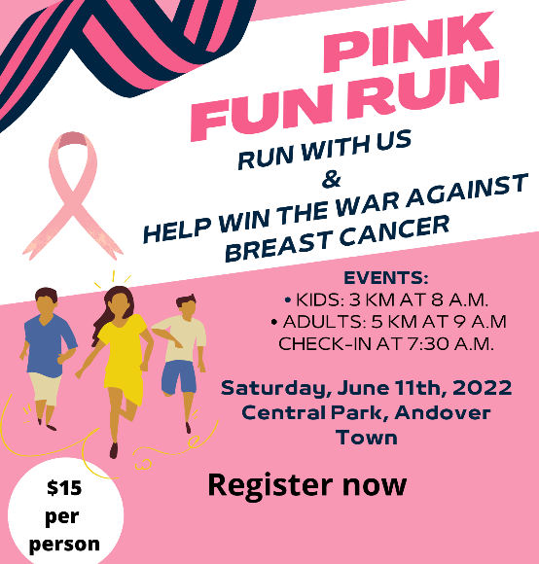 | A. You have to wear a pink uniform.  B. There are events for both children and adults.  C. It’s free to take part in the fun run.  D. You can check in at 8 a.m.
IV Write the correct form of the words in brackets.(0.5point)
1. My sister, Sonya, is a food lover. She often eats __________ food, such as rice, vegetables, fruit, and fish. ( HEALTH)
2. Take part in community ________. You can pick up rubbish on the streets, sidewalks, beaches and parks, or clean the graffiti off the walls. ( CLEAN)
PART C. READING: (2.5 points)
I.Read the following passage and answer the questions (1.25 point)

Hi, I’m Alex. I used to drink lots of fizzy dinks like cola and soda, but last year I changed my habit. I started drinking lots of water because it is important to our bodies.
Our bodies are about 60% water. That means we have more water than bone. When we exercise, our bodies lose up to 10% of their water. We need to drink more to replace that water and perform well. Drinking water also helps our brain work better. Also, our skin looks brighter and our body temperature stays the same even on a hot day, all because of the water inside us.
So how much water should we drink? Most experts suggest around eight glasses a day. Other drinks such as tea, milk and fresh fruit juice are OK too. What about you? Do you dink enough water?
- Alex started drinking fizzy drinks last year.
- Our bodies have more bone than water
- We lose a lot of of our water when we exercise.
- Our skin doesn’t change when we drink water.
- Experts think eight glasses of water per day is too much.
II. Read the review; for questions from 38 to 42, complete each blank with a suitable word in the box. There is ONE extra word that you don’t need. (1.25 point)

entertaining satisfy scenes characters setting set

Raya and the Last Dragon is a Disney animated movie. It is (1) .............. in Kumandra, a fantasy world. The main (2) ………… are Raya, a lovely and powerful princess and Sisu, a sweet and optimistic dragon. Long time ago in Kumandra, people and dragons lived together happily. However, the evil monsters Druun appeared and turned everything in their paths to stone.
Therefore, Raya and her beloved friend Tuk Tuk, a giant pill bug, were on a mission to find Sisu, the last dragon. Together, they travelled to the rest of Kumandra’s regions, teaming up with other people to stop the Druun forever.
The animation is really impressive. They designed the dragons so beautifully and they managed to make a super cute bug, Tuk Tuk. The setting is really good, but some (3) …………….are quite dark and scary. In my opinion, the best thing is the music. The main theme song stayed in my head for a long time after the film was over.
Overall, Raya and the Last Dragon is enjoyable and (4) …………. It teaches us how to forgive and trust other people. I believe this movie will (5) ___..................every Disney’s fan.
PART D. WRITING: (2.5 points)
I. Use the given words or phrases to make complete sentences. (0.5point )
1. Emma / breakfast / a carton / had / for / a / milk / of / sandwich / and
-> ………………………………………………………………………………………
2. Taylor Swift / wonderful / is / my/ are / favorite /always / singer; her/ performances
-> ………………………………………………………………………………………
II: Rewrite the following sentences without changing their original meaning.
(1.0 point)
1. We should have a bake sale to raise money for our football uniforms.
→ How about …………………………………………………………………………
2. When you have a fever, it’s not a good idea to go to school.
→ You shouldn’t ………………………………………………………………………
3. I like blues more than reggae.
→ I prefer……………………………………………………………………………
4. I’m interested in cycling in the park.
→ I think cycling ………………………………………………………………
III. Write a paragraph (about 60-80 words) about your hobby. (1.0m)

- THE END -
- Học sinh làm bài vào tờ giấy kiểm tra và không được phép sử dụng tài liệu. Giám thị coi kiểm tra không giải thích gì thêm.

Họ tên học sinh…………………………….Lớp:…………….SBD………….
Chữ ký giám thị:………………………………………………………………
PHÒNG GD&ĐT THỊ XÃ ĐÔNG TRIỀU  TRƯỜNG THCS ĐỨC CHÍNH | ĐÁP ÁN - BIỂU ĐIỂM CHẤM KIỂM TRA  GIỮA HỌC KỲ I NĂM HỌC: 2022-2023  MÔN: TIẾNG ANH 7

PART A. LISTENING: (2.5pts )
I. 1.25pt (0.25pt/ each correct answer)
Numbers | 1 | 2 | 3 | 4 | 5
Keys | D | A | E | C | B

II. 1.25pts (0.25pt/ each correct answer)
Numbers | 1 | 2 | 3 | 4 | 5
Keys | B | A | C | D | B

PART B. USE OF ENGLISH: (2.5pts )
I. 0.25pt
Numbers | 1
Keys | B

II. 0.25pt
Numbers | 1
Keys | C

III. 1.5pts (0.25pt/ each correct answer)
Numbers | 1 | 2 | 3 | 4 | 5 | 6
Keys | C | D | D | B | A | B

IV.0.5pt (0.25pt/ each correct answer)
Numbers | 1 | 2
Keys | B | A

PART C. READING: (2.5pts)
I.1.25pts ( 0.25pt/ each correct answer)
1. The most important tip for a healthy body/ It is to have healthy food, eat them at right time and avoid eating junk food.
2. Your diet/ It should include vegetables, fruits, milk, and fish.
3. 8 hours a day.
4. Healthy food.
5. Healthy body
II. 1.25pts ( 0.25pt/ each correct answer)
Numbers | 1 | 2 | 3 | 4 | 5
Keys | A | B | A | C | A

PART D. WRITING: (2.5pts)

I. 0.5 pt (0.25pt/ each correct answer)
1. We collect old clothes and food to provide to the homeless people.
2. Ha likes going on a picnic with her best friends at weekend.
II. 0.5 pt (0.25pt/ each correct answer)
1. Because Hoa was sick, she couldn’t go to school yesterday.
2.He likes playing the piano in his free time
3. You should stop smoking because you are not healthy
4. I would like to make a big cake for my mother’s birthday

III. 1.0pt
OPEN ANSWER
- Good content, ideas: 0.5 pt
- Good organization and coherence: 0.25 pt
- Exact structures and vocabulary: 0.25 pt

- THE END –

\

