Unit 10: Staying healthy
Lesson 2: A3-4,6
A. Objectives: By the end of the lesson, the sts can know how to read a dialouge and recognize polite offers and request.
B. Teaching aids: pictures, cassette, flash card.
C. Methods: pair work, guessing.
D. Contents:
I-Organization:

Class……… Date of teaching…………………………………… Absent Ss:………
……… …………………………………… ………
II- Warm up and Revision: ( 5’ )

III- New lesson
Teacher and sts’ activities | Contents
Step 1: Warm up  -Ss ask and answwer about the picture of A 1 / 104 (pair work)  Step 2: Pre-reading  T: plays the tape and ask sts to listen carefully.  Sts : listen  T: -explains some news words  - read the new words.  - Play the tape again and let sts repeat  Sts : - Repeat after teacher .  - Listen and copy down.  - Repeat (chorus) then work in pairs.  -Let Ss listen the dialouge and conplete the it, without looking their books.  -Give feedback  T: explain the grammar.  -Ss listen  Step 3: While –reading  -Ss read the dialouge and check their prediction.  -Give answwer key.  -T reads the dialouge  -Ss listen and repeat.  Ss read it again and match the key words to the people.  -Let Ss look at the form and practice asking and answering  -Guide ss to read the dialouge then make the same dialouge ( give statements)  Step 4: Post-reading (A 6)  -Ss read the dialouge and check  Then make the same dialouge  S1: How does Lan feel?  S2: She is thirsty  S1: What would she like?  S2: She’d like some orange juice  What’s the matter with you? | S1: How does he feel?  S2: He is full  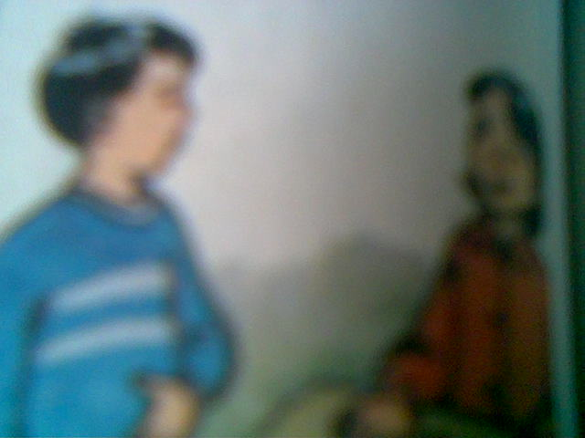  1.Vocabulary :  - juice (n) (trans): nước trái cây  - orange juice (n) (trans): nước cam  - drink (n) (examp): đồ uống  - noodles (n) (trans): phở, bún...  - would like (‘d like) = want (v) (trans): muốn  - would not = wouldn’t  2. Predicdialouge  Nam: How do you feel?  Lan: I’m .hot.......... and ...thirsty...........  Nam: What would you like?  Lan: I’d like some...orange juice........what about you?  Nam: I’m...hungry..... I’d like some …noodles…  * Grammar: Would you like....?  - Hỏi ai muốn điều gì một cách lịch sự  What would you like?= what do you want?  - Ðưa ra lời mời lịch sự  Would you like a cup of tea?  Would you like to go with us?  +Responses  (+)Yes, plase.  (-) No, thank you.I;m not thirsty.  No, I’d like a glass of water.  +Checking prediction  +Matching (with answwer key)  a.hot / cold / drink  b. hungry / noodles  c.thirsty / a drink.
   | Lan | Nam | Ba
  hot | hot
  tired |  |  | tired
  thirsty | thirsty
  full
  hungry |  | hungry
  noodles |  | noodles
  a drink/ orange juice | drink
  to sit down |  |  | to sit down

IV- Summary(2’): to read a dialouge and recognize polite offers and request.

V- Homework(3’): - Learn all the structures by heart and do exercises
- Prepare next part (B 1-3)
E. Evaluation
............................................................................................................................................................................................................................................................................................................................................................................................................................................................................................................................................................................................................................................................

