Unit 10: Staying healthy
Lesson 1: A1-2,5

A. Objectives: By the end of the lesson, the sts can tall about how we feel using adjectivea of physical state.
B. Teaching aids: pictures, cassette, flash card.
C. Methods: pair work, guessing, communicative approach.

D. Contents:
I- Organization:
Class……… Date of teaching…………………………………… Absent Ss:………
……… …………………………………… ………

II- Warm up and Revision: ( 5’ )
- What time is it ?
- What's today, class ?
+ Revision : Ex 5 / p61
III- New lesson.

Teacher and Sts’ activities | Contents
Step 1: Warm up  -T sticks the picture of B 4 / 101 on the board.  -Then ask Ss to describe about ‘Chi’  -Call on one student.  -Ss work in pairs, take it in turns to point at the different pictures on page 104, 105 and ask and answer  S1; What’s this color?  S2: It’s green.  Step 2: Presentation  -T introduces new words by using the pictures  -read the new words.  -Play the tape again and let sts repeat  Ss : - Repeat after teacher .  - Listen and copy down.  - Repeat (chorus) then work in pairs.  Sts match the words in column A with the one in column B  - Point the picture then ask and answer.  -Ss listen and guess.  - Explain and give model structures  Step 3:Practice  Let Ss practice in paurs  -Stick pictures of A 1 and A 5 /106  -Ss practice asking and answering in pairs  Ss listen and match the right numbers with the pictures  -Give feedback  Step 4: Consolidation  -Ask a student to think the feeling but without talking  -The rest of the class asks him or her to find out the feeling.  The student can only answer yes /no | 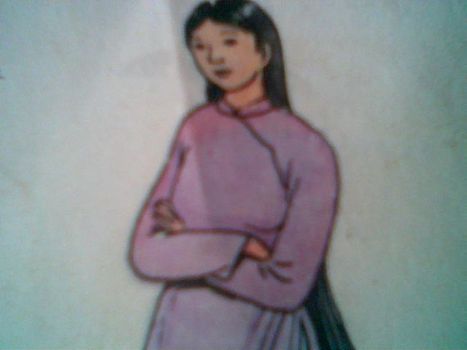  1. Pre-teach: Vocabulary :  -hungry(adj): đói  -thirsty (adj): khát  -full (adj): no, đầy  -hot(adj): nóng  -cold (adj): lạnh  -tired(adj): mệt  - to feel (trans)  *Checking: Matching  2. Structures  Hỏi đáp về cảm giác  How + do + you /we/ they + feel?  How + does + she / he + feel?  I am  She /He is + adj (thirsty)  You / we /they are  3. Practice  *Word cue drill  Ex: How do you feel?  S2: I’m hungry.  *Picture Drill  S1: How does she/ he feel?  S2: She /He feels thirsty  *Matching ( A 5)  Phýng: b Nhan: a Ba: f Hýng: d  The tape transcript:  Nhan is hungry. He’d like noodle.  Phuong is thirsty. She’d like a drink.  Ba is full  Huong is cold.  *. Guessing game  Ex:S1: Are you thirty?  S2: No, I am not  S3: Are you hot?  S2: Yes, I am
  hungry  thirsty  full  hot  cold  tired | lạnh  nóng  đói  khát  mệt  no
  hungry | thirsty | hot
  cold | tired | full

IV- Summary(2’): tall about how we feel using adjectivea of physical state.

V- Homework(3’): - Learn vocabulary
- Make 4 sentences with the structure above

