Unit 14: wonders of the world
Lesson 1: Getting started + Listen and read

I/ Aims
- To help students read the text for details.
- To help students practice seeking information.
can repost what people ask and answer about one of the world cultural Heritage of Viet Nam
II/ Objectives
- By the end of the lesson, students will be able to:
+ understand the text for details.
+ know how to summarize from the dialogue / how to seek information.
+ report what people ask and answer about one of the world cultural Heritage of Viet Nam
III/ Teaching aids:
- Textbook, pictures in the textbook, tape and cassette player.
IV/ Ways of working:
Teacher – Whole class, individuals, pair work, team work
V/ Procedures
Teachers’ activities | Students’ activities
1.Warm up :  Getting started:  Quiz :  - Inform the topic : Wonders of the world  - T. gives Ss some postcards or pictures of the famous world landmarks or scene sports in Vietnam  - T. shows the pictures , one by one to Ss and asks them what place it is  -T .has Ss look at the pictures on page 131 and do the matching    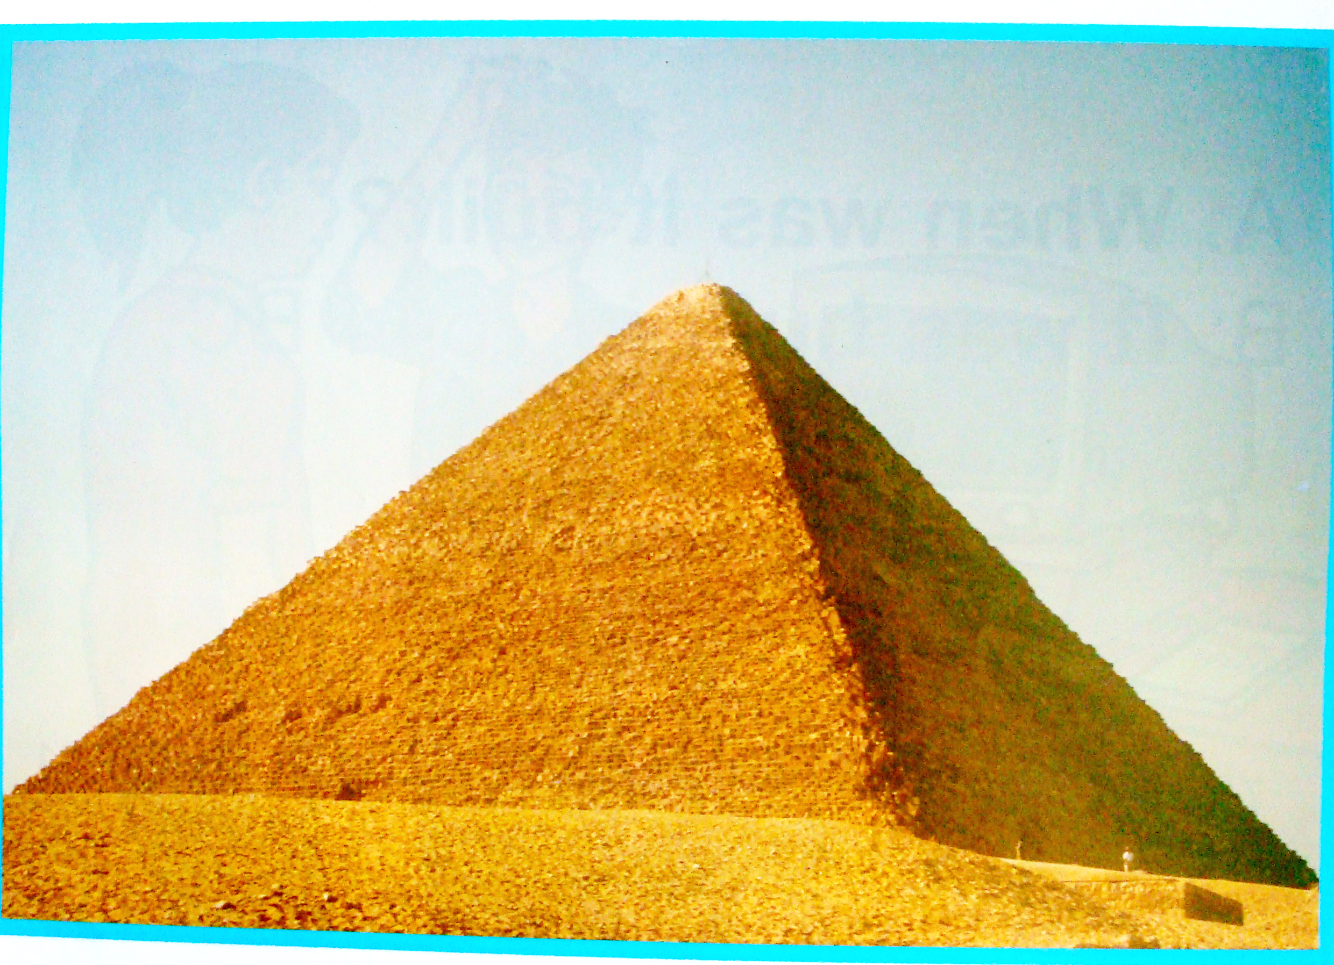    2. Presentation :  Listen and read:  * Pre teach vocabulary  - a landmark : a place  - a clue : suggestion  - (to) suggest : gîi ý, ®Ò nghÞ, ®Ò xuÊt  * Rub out and Remember to check understanding.  - Set the scene :  “ Nga, Nhi and Hoa are playing a language game called guessing game. How does this game work ? Rearrange the Statements in the right order of the game “  - How to play the guessing game :  - B asks questions to find out who or what is  - A thinks of a famous person or place  - B wins if he / she can guess the correct answer  - A gives B a clue  - B loses if he /she cannot guess the correct answer  - A can only answer “ yes “ or “ no”  - T .puts the statements chart on the board  - T. asks Ss to read the statements and put them in the right order  - T. calls some pairs to go to the board and write their answers  3. Practice :  - T. asks Ss to open their books and read the dialogue on page 131,132 while listening to the tape  - T. plays the tape  - T. checks if Ss’ guesses are right or wrong  - Have ss copy the statements in the right order  - Have Ss read the dialogue again and complete the summary (2) on page 132  - Ask Ss to compare their answers with their partners  - Have some Ss give their answer  - Elicit the target language by asking Ss a question ( in Vietnamese )  4. Production:  Teacher asks students to look at LF 3 and do the exercise.  Teacher lets students resay the sentnces first, then ask them write down.  Teacher calls on some students to go to the board and write the sentences.  Teacher corrects.  5. Homework:  Learn by heart new words.  Practise reading dialogue again  Prepare: Speak | - Answer key :  - The Pyramid  - Sydney Opera House  - Stonehenge  I. Vocabulary  - a landmark : ®Þa danh  - a clue : gîi ý, ®Çu mèi  - (to) suggest : gîi ý, ®Ò nghÞ, ®Ò xuÊt  II. Practice :  1. Ordering  * Answer key :  2- A thinks of a famous person or place  4- gives B a clue  1- B asks questions to find out who or what is  6- A can only answer “ yes “ or “ no”  3- B wins if he / she can guess the correct answer  5- B loses if he /she cannot guess the correct answer  2. Gap fill  Answer key :  - game  - place  - clue  - Vietnam  - America  - golden  - right  - was  3. Model sentences :  Ex : I don’t know how I can play it  Where to go  → Indirect question  S + V + question word + to infinitive ………  Langua focus 3  Question words before to infinitive  Ex:  Nga told Nhi How to go there  S + V+ Question word + to -infinitive  Answer:  b) Nga showed Nhi where to get tickets.  c) Nga pointed out where to buy souvenirs.  d) Nga advised Nhi how to go from My Son to Hoi An  e) Nga told Nhi what to do there during the visit  III. Homework:  Learn by heart new words.  Practise reading dialogue again  Prepare: Speak

