Unit 9: The body
Lesson 1: A1-2
A. Objectives: By the end of the lesson, students will be able to learn some nouns to talk about parts of the body
B. Teaching aids: Text book, , T’s book, cassette, flash card ,sub-board
C. Methods: T,WC, pairs, rub out and remember, simon says...
D. Contents:
I- Organization:
Class……… Date of teaching…………………………………… Absent Ss:………
……… …………………………………… ………
II-Warm up and Revision: ( 5’ )
III- New lesson:

Teacher’s and students’ activities | Contents
Step 1: Warm up  - Play “ Shark attack “  Ss: do as direct  Step 2: Presentation  - Use the picture to introduce parts of the body  Ss: look at the picture and listen to the teacher  - Say the new words as pointing to the picture and ask Ss to repeat  Ss : listen and copy down - repeat  - Play the tape again and get Ss to repeat ( chorus – individual)  Ss: do as directed  - Label the black board picture as you pre-teach.  - Rub out and remember the labels  - Get Ss to re-label the picture  Step 3: Practice  - Have Ss play game “ Simon says “  Ss : do as directed  Simon says touch your left hand  Simon says touch your fingers  Touch your left foot!  Simon says touch your left foot  Simon says touch your right foot  Touch your head!  Touch your toes!  Simon says touch your toes  - Ask Ss to practice in pairs  Ss: Do as directed  Step 4: Consolidation  - Call 2 students go to the board (A student shows him/herself and call out name parts of the body, other writes on the board.)  - Correct the mistakes | Warm up  *Shark attack  - - - - body  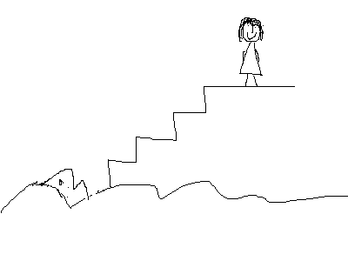  1. Listen and read.  * Vocabulary :  - head (n): ®Çu  - chest (n): ngùc  - shoulder(s) (n) vai  - arm(s) (n):c¸nh tay  - hand(s) (n): bµn tay  - leg(s) (n.): c¼ng ch©n  - finger(s) (n) ngãn tay  - toe(s)(n): ngãn ch©n  - foot – feet (n): bµn ch©n  * Check: Rub out and remember  head  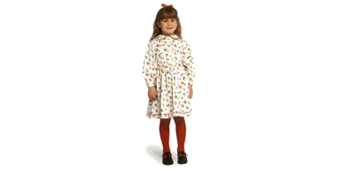  * Simon says  Simon says touch your head  Simon says touch your chest  Simon says touch your feet  Touch your shoulders!  Simon says touch your shoulders  Simon says touch your legs  Touch your head!  Touch your shoulders!  Simon says touch your head  2. Practice with a partner  Picture drill (A1-P.96)  * Ex: A2 (P.97)  A: What’s that?  B: That’s his [ head]  A: What are those?  B: Those are his [shoulders]  * Writing
IV- Summary:(3’): - to talk about parts of the body
V- Homework:(2’) - Learn the new words & write all the answer in the notebooks
- Prepare : Unit 9 :
E. Evaluation
..............................................................................................................................................................................................................................................................................................................................
............................................................................................................................................................................................................................................................................................................................

